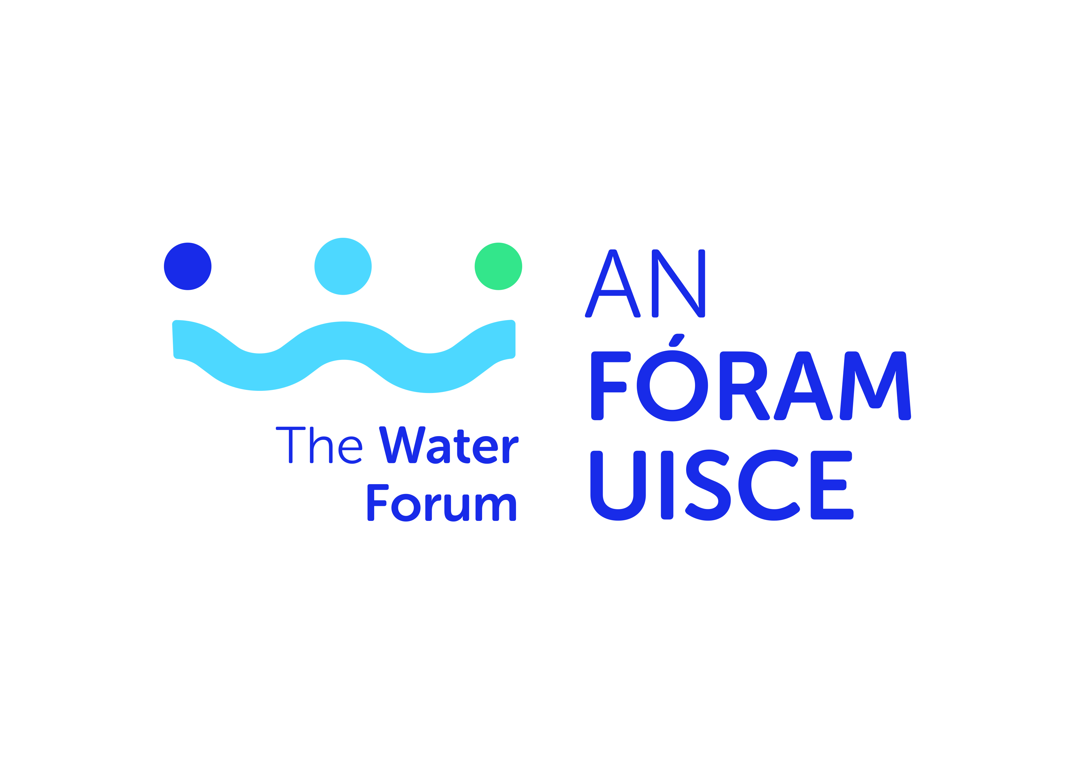

Request for Research Tender on Understanding the Constraints of, and Developing Pathways for Improving the Management of Invasive Alien Species in the Republic of Ireland

APPLICATION FORM
Application Form Guidelines
- All sections must be answered.
- Please ensure your application has been signed by all parties
- Please read in full, the terms and conditions for this application before submission
- All queries should be directed to Dr Alec Rolston by email to alec@nationalwaterforum.ie
- All completed applications should be submitted electronically to alec@nationalwaterforum.ie by 1700 Monday 9 November 2020.
6: Late or incomplete applications will be deemed ineligible. This will be
strictly enforced.

- Lead Investigator Details

Please attach updated CV (max 4 pages) incorporating the following as appropriate: education, experience and/or details of research and published works.

Name
Organisation/Education institution
Research Centre/Group (if applicable)

Email
Telephone
Position

2. Project Proposal

Project Title | Understanding the constraints of, and developing pathways for improving management of Invasive Alien Species in the Republic of Ireland.
Total Project Cost
Proposal description which demonstrates a clear understanding of the brief and requirements of the project
(1000 words maximum)
Project management arrangements
(500 words maximum)
For consortium applications, please outline the expected role/contribution for each consortium member
Timeline incorporating deliverables and Gantt chart
(500 words maximum)
Proposed Budget and justification
(500 words maximum)

Institutional Sign Off

Lead investigator | Name:  Signature:  Date:
Research Office or equivalent | Name:  Signature:  Date:

