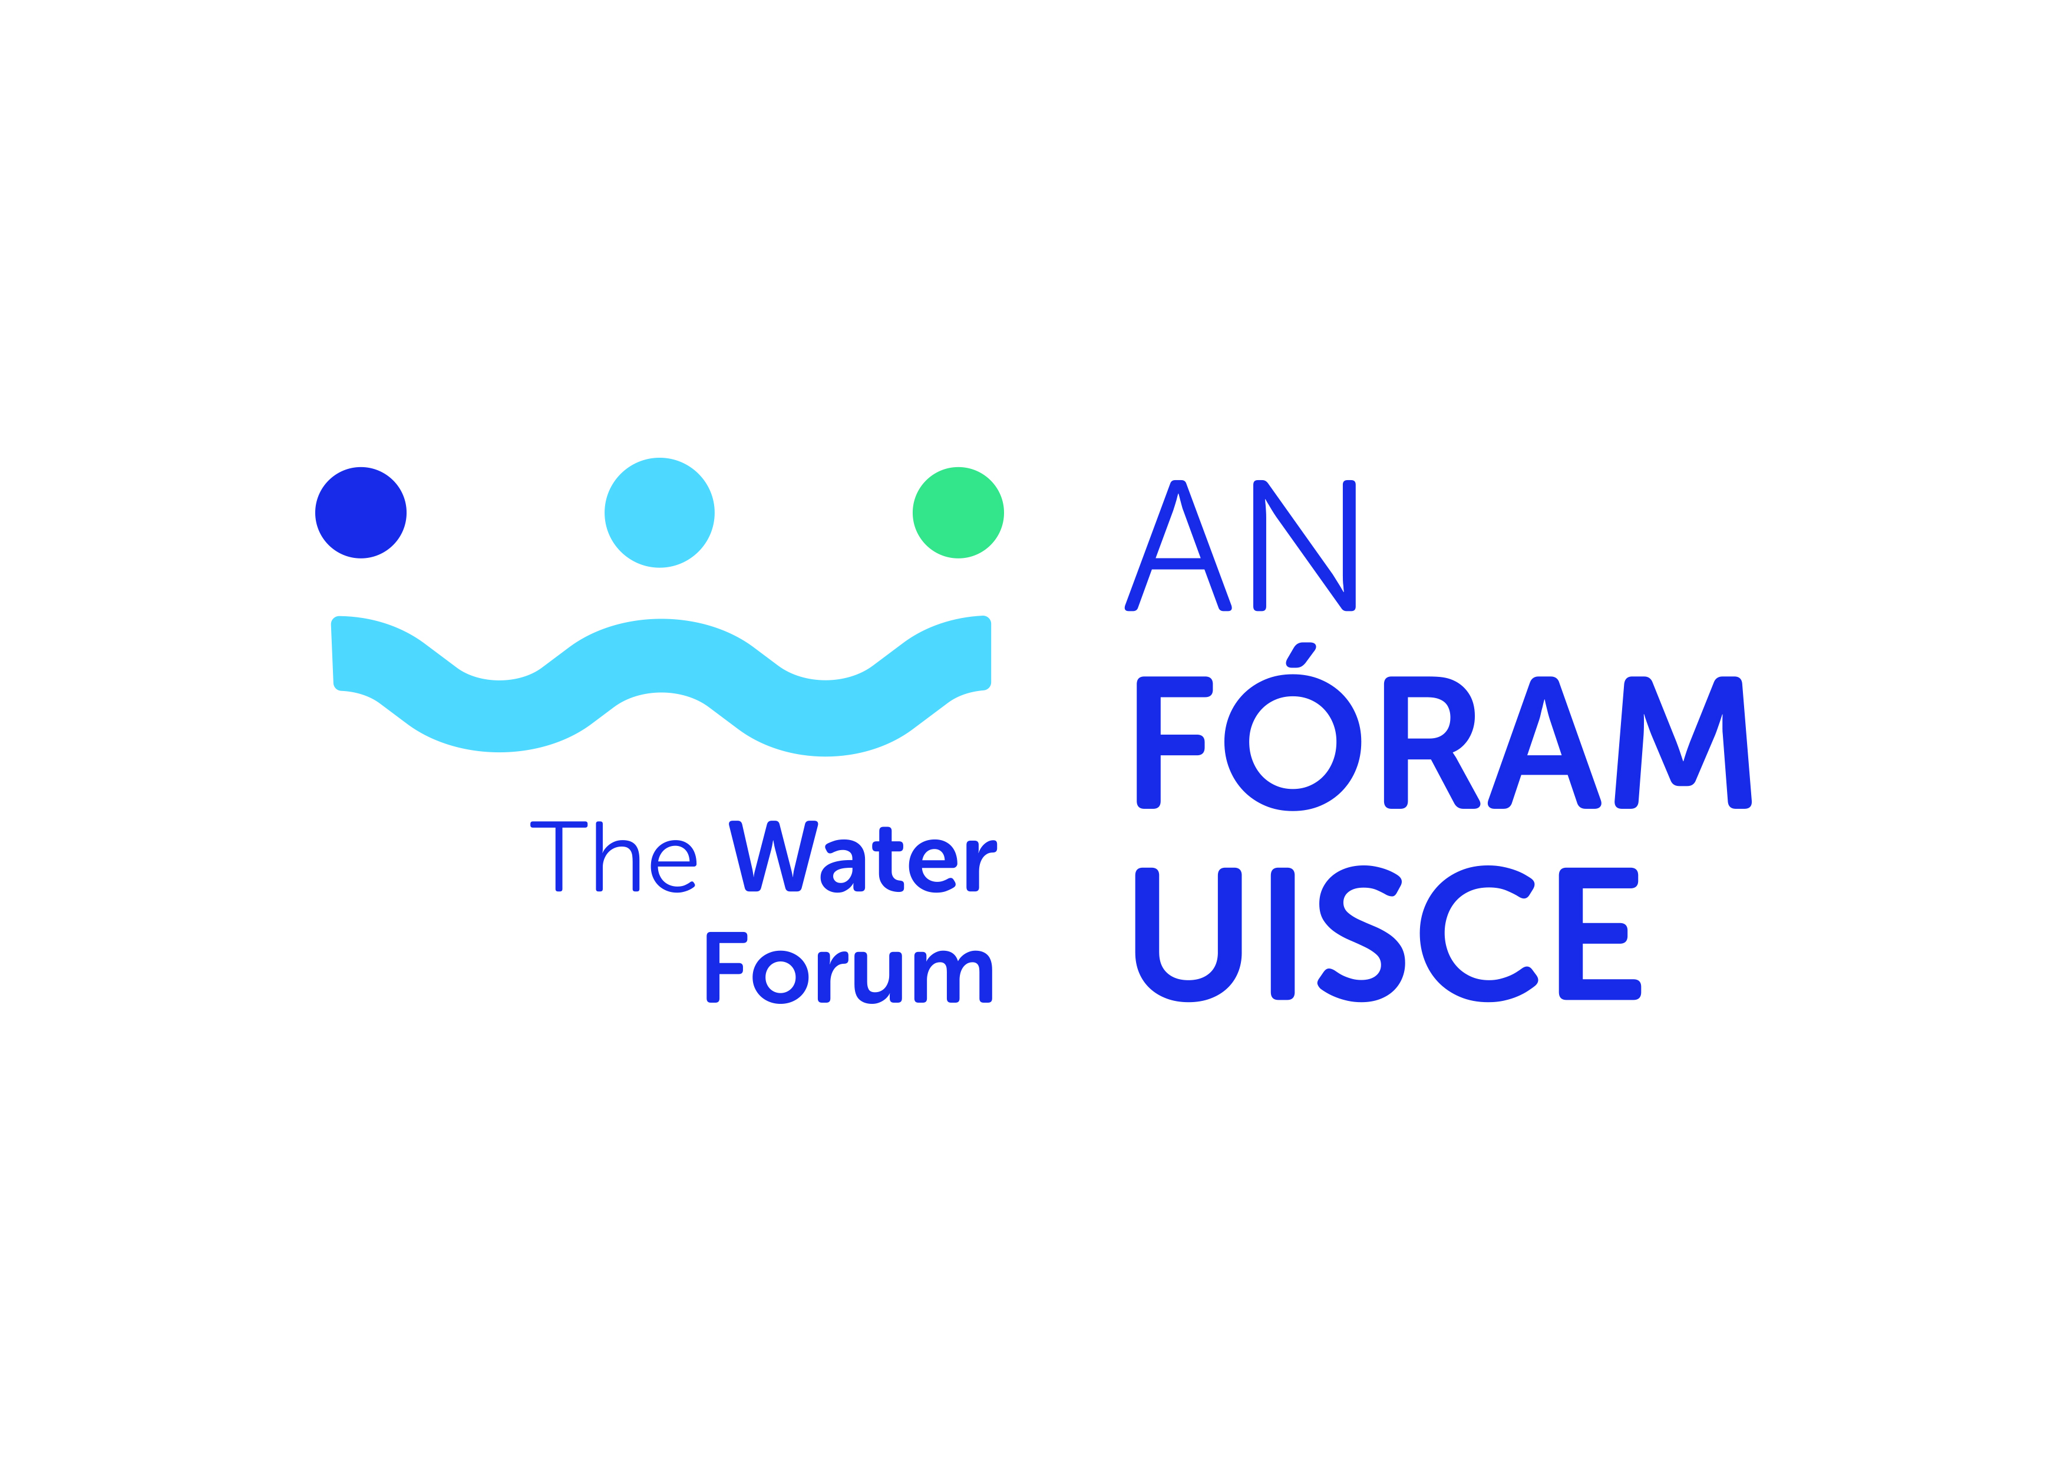

EARLY STAGE RESEARCH BURSARIES

APPLICATION FORM
Application Form Guidelines

- All sections must be answered.
- Please ensure your application has been signed by all parties
- Please read in full, the terms and conditions for this application before submission
- All queries should be directed to Dr Alec Rolston by email to alec@nationalwaterforum.ie
- All completed applications should be submitted electronically to alec@nationalwaterforum.ie by 1700 Monday 28 September 2020.
6: Late or incomplete applications will be deemed ineligible. This will be
strictly enforced.

- Early Stage Researcher Details

Please attach updated CV (max 4 pages) incorporating the following as appropriate: education, experience and/or details of research and published works.

Name
Organisation/Education institution
Research Centre/Group (if applicable)

Email
Telephone
Position

- Brief description of current, ongoing research topic (e.g. PhD/Postdoctoral topic)
(250 words maximum)

3. Bursary Proposal

Topic Number |  | Topic Title
Proposal description which demonstrates a clear understanding of the brief and requirements of the project
(1000 words maximum)
Project management arrangements including names and affiliations of supervisors
(500 words maximum)

Timeline for project completion outlining project actions and incorporating deliverables and Gantt chart
(500 words maximum)
Statement as to how this bursary will help to achieve research and career goals
(500 words maximum)

Institutional Sign Off

Early Stage Researcher | Name:  Signature:  Date:
Primary Institutional Supervisor | Name:  Signature:  Date:
Research Office or equivalent | Name:  Signature:  Date:

